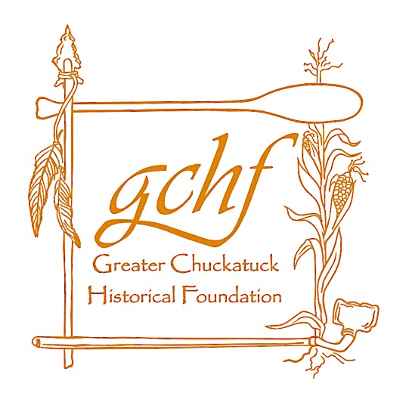
Founder’s Day
Vendors Contact:
Beverly Vaughan
(757) 355-1544
annlovell923@gmail.com

coc
Saturday, October 24, 2015
10 am – 3 pm
Vendor spaces will be located at
Chuckatuck Volunteer
Fire Department
300 Kings Hwy Suffolk, VA.
VENDOR APPLICATION
(Application due by Oct. 10, 2015)

CONTACT NAME: _________________________________________________________________
BUSINESS NAME: _________________________________________________________________
ADDRESS:
_________________________________________________________________
_________________________________________________________________
EMAIL ADDRESS: _________________________________________________________________
PHONE NUMBER: _____________________________________________

Please describe what you will be selling
(list specifics if you are not a direct sales company):
__________________________________________________________________________________________________
___ Indoor space (6’ table) x $50 each
Indoor vendors will be using the provided 12’ folding tables with two 6’ vendor spaces per folding table.
___ Outdoor space (10’x10’) x $40 each
Outdoor vendors must provide their own tents and tables.
Total amount due: _________

Checks/Money orders should be made out to:
Greater Chuckatuck Historical Foundation
P.O. Box 2384
Suffolk, VA 23432

Vendors must:
- Be responsible for set up by 9 AM and clean up by 3:30 PM,
- Have someone at their assigned space at all times during the event,
- Make sure to be in compliance with business and sales tax requirements during event, and
- Pay for the space before the event.

- Application fee is non-refundable.
- Vendor’s application will be confirmed through email.
- Only one application per business will be accepted.
- Vendor may not replace business on application with another business.
- Electricity is not guaranteed.
- CVFD and the GCHF will be held harmless of any and all liability while Vendor participates in this event.
Vendor signature: ________________________________________ Date: _______________________

